12.24: a) 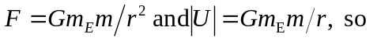the altitude above the surface of the earth is 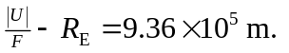 b) Either of Eq. (12.1) or Eq. (12.9) can be used with the result of part (a ) to find m, or noting that 